**Screenshot of My Online Resume: -**

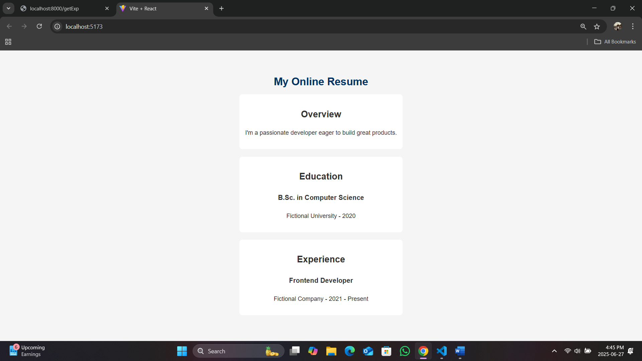

**Screenshot of getOverview: -**

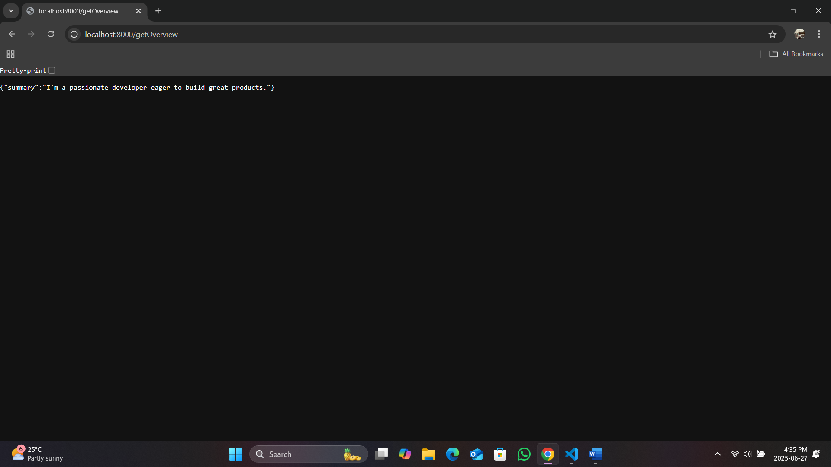

**Screenshot of getEdu: -**

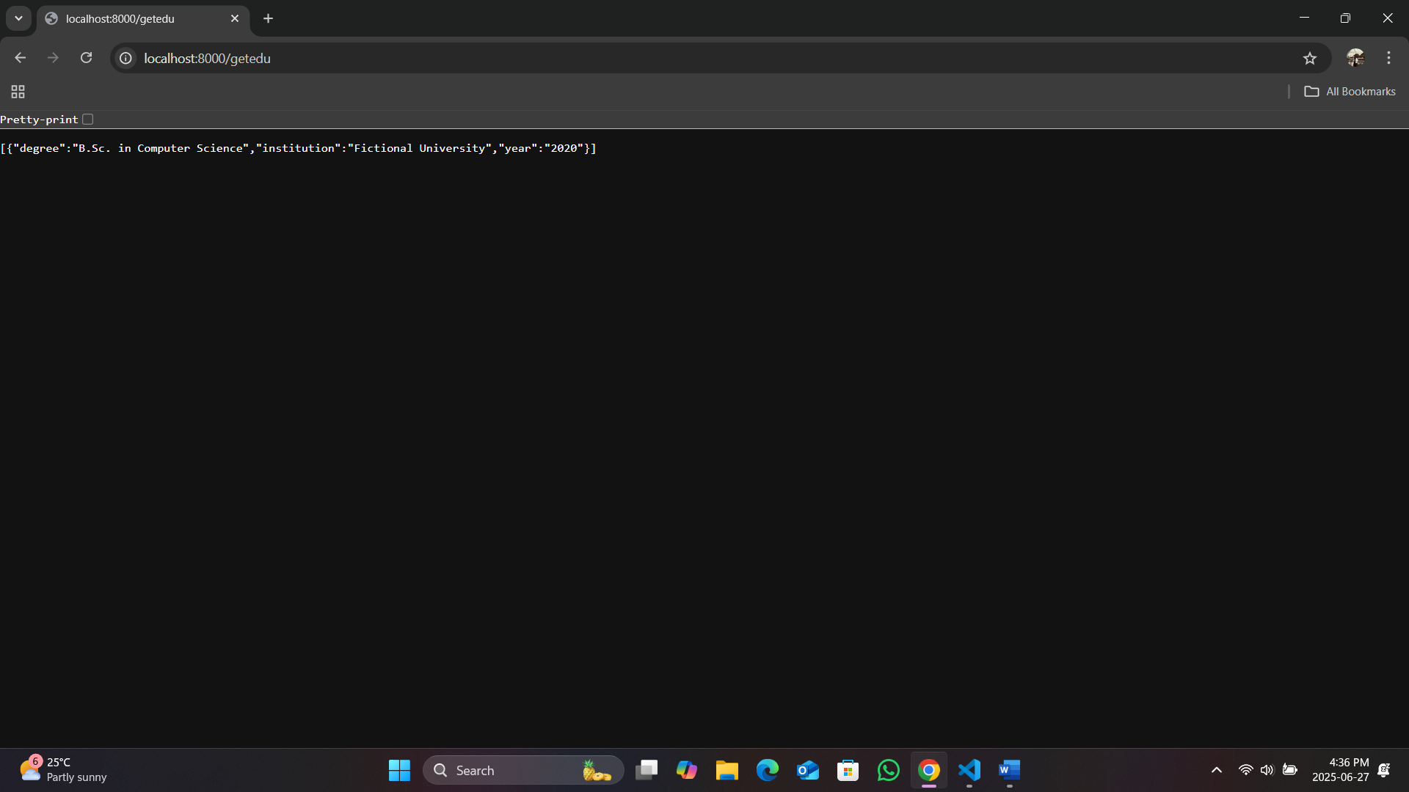

**Screenshot of getExp: -**

